Green Energy Transition: Costs and Opportunities

1. Abstract:
It is undeniable that the transition from fossil fuels to renewable energy sources is a crucial step towards achieving sustainable development and mitigating the upcoming dangers of climate change. This research paper examines the economic implications- discoveing the costs and oppurtunites which green energy transition poses. Specifically focusing on the costs of building renewable energy infrastructure and on the potential for job creation in renewable energy sectors. Also discovering the impact of the neglect of fossil fuels and the lessons from case studies of leading countries and regions. Key findings highlight that, while the initial investment in renewable energy may cause financial burden, long-term benefits may outweigh the costs such as reduced energy costs, significant job creation, and enhanced energy security. As well as that, research in this paper from case studies reveal the importance of policies and technological advancements in helping with the transition. The research conducted concludes that despite the initial challenges and burden, green energy transition presents a transformative opportunity for economic growth and environmental sustainability, explaining the positive impact which is necessary for the future. [1], [2], [3]
The findings suggest that the shift towards clean energy requires substantial initial investment, along with improvements in grid infrastructure, technical capacity, and workforce skills. However, these challenges may be balanced by long-term benefits, including lower energy costs, reduced carbon emissions, greater energy independence, job creation, and wider economic diversification. The study also highlights the importance of supportive government policies, public–private partnerships, education, and continued investment in research and innovation. [1], [2], [4]
Overall, the UAE’s clean-energy transition should be viewed not only as a response to environmental concerns, but also as an opportunity to strengthen economic resilience and build a more sustainable energy system for the future. [3]
Index Terms— Clean energy, renewable energy, energy transition, sustainable development, energy infrastructure, United Arab Emirates.

2. Introduction
The global shift away from fossil fuels and towards renewable energy is now a matter of compulsion rather than choice, driven by the urgent needs of climate change, energy security, and sustainable development. For the UAE, historically reliant on oil and gas, this transition is as much a revolutionary ePushing for cleaner energy means countries must lessen their reliance on fossil fuels. Cleaner energy sources help solve many related issues including climate change, the demand for energy, and the security of energy. The fossil fuels economic boom has tied the history of many developing nations to oil and gas. Developing nations must undertake a major transformation, changing their policies and technologies, how they employ and invest, and how they generate electricity. [1], [3]
The transition occurring in the United Arab Emirates exemplifies these efforts. As a major oil and gas producer, we see how the UAE has started investing heavily in technologies for solar energy, nuclear energy, storage for energy, smart grids, and green-hydrogen. Projects such as the Barakah Nuclear Power Plant and the Mohammed bin Rashid Al Maktoum Solar Park show the efforts of the UAE to lessen the impact their economic growth have on the environment and diversify their energy systems. Nuclear energy is a low-carbon energy source and both of these technologies help the clean energy strategies of the UAE along with renewable solar energy. [5], [6], [3]
Shifting towards a cleaner energy system proves quite difficult. Major improvements to infrastructure, the energy grid, and energy storage systems as well as a large capital investment are required for solar and other renewable energy projects. Adding new technologies that have to be integrated into systems originally built to use conventional fuels further adds economic and technical stress on the infrastructure built to use conventional energy.conomic shift as it is an imperative of strategy. As the world and nation more and more depend on energy, the country has begun investing heavily in renewable energy infrastructure in the form of visionary projects like the Mohammed bin Rashid Al Maktoum Solar Park and Barakah Nuclear Power Plant. These projects reflect the country's commitment towards diversifying energy resources, reducing carbon emissions, and establishing long-term economic resilience.
At a significant cost, however. huge infrastructure development entails huge upfront investment, technical and logistics challenges, and requires human resource adjustment. All the above short-term problems are weighed against long-term benefits in the form of reduced energy expenses, job creation in new green industries, and enhanced energy independence. This paper analyses UAE's evolving energy landscape, with a focus on the economic importance, infrastructural needs, job creation, and the central role played by policy environments and training. By analyzing national programs and local experience, it illustrates how the UAE can lead a sustainable, strategic, and economically prudent energy transformation. This long-term advantage of sustainable investment is further reflected in real estate trends: as shown in Figure 1, LEED-certified assets in Abu Dhabi consistently achieve higher occupancy rates than non-LEED-certified assets, reaching over 95% in 2023 compared to around 89% for non-certified buildings. This illustrates how green infrastructure, though initially costly, secures stronger market demand and resilience over time. [1], [7]
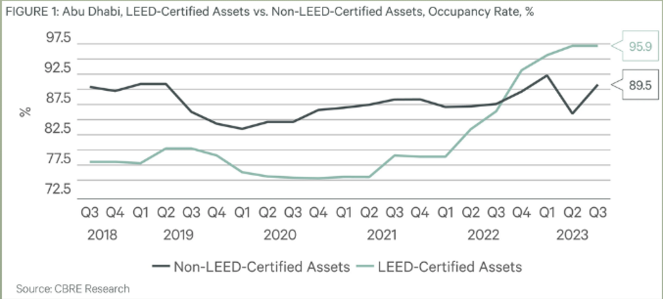
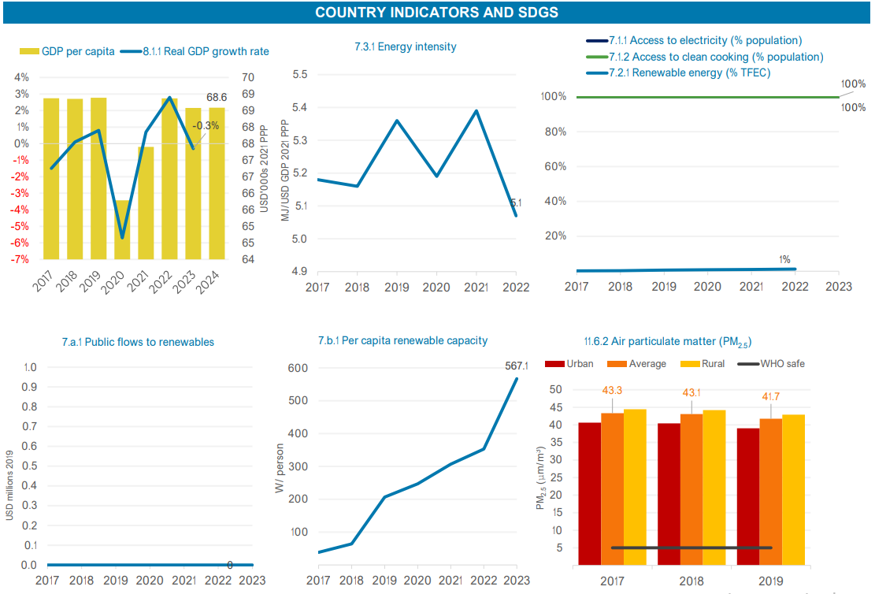
Figure 1 CBRE Research [7]

3. Discussion

3.1 Economic Implications
Although posing many possible benefits, the UAE's transition to renewable energy would require substantial initial capital investment, which could represent an opportunity cost, particularly for large-scale infrastructure projects that take time to construct and would impose almost immediate financial burdens. One prominent example illustrating the future economic implications is the Mohammed bin Rashid Al Maktoum Solar Park in Saih Al-Dahal, which is estimated to have a construction cost of AED 50 billion. Many may argue, despite the high upfront costs, the long-term economic gains the country would experience present a compelling counter-argument to these upfront deposits. Additionally, according to the International Renewable Energy Agency (IRENA), reaching a 10% share of renewable energy in the UAE’s energy mix could yield annual savings of approximately USD 1.9 billion by 2030, highlighting a true projection of benefits for the economy. Furthermore, when we factor in positive externalities like health and environmental co-benefits, net savings could increase by another USD 1 to 3.7 billion annually, due to the large-scale shift to this type of technology. The declining costs of renewable technologies, such as photovoltaic systems, further enhance their economic viability and improve the feasibility of transitioning to green energy, and reinforce the idea that the transition is also fiscally strategic. This argument aligns closely with the UAE’s carbon reduction trajectory shown in Figure 2, where emissions are expected to drop steadily from around 200 million tonnes in 2019 to net zero by 2050, indicating how economic investments today are directly tied to long-term environmental and fiscal stability. [5], [2], [8]
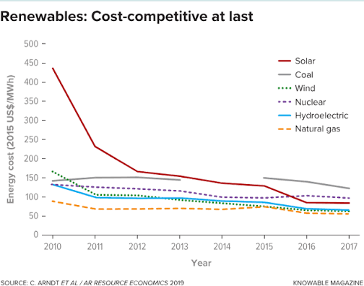

3.2 Infrastructure Development
Additionally, a fundamental component of the UAE’s energy transition involves the expansion and modernisation of its energy infrastructure, which is an important step towards a more smooth green enegry transistion. This would include integrating new renewable energy sources into the national grid in the UAE, alongside developing new energy storage systems, and improving grid resilience for longevity of the Green Energy. All of these methods will enhance over time as technology becomes more efficient. Notably, The International Energy Agency (IEA) is an organisation which stresses the importance of building or upgrading 25 million kilometers of electricity grids and establishing 1,500 gigawatts of energy storage globally by 2030 [9], providing evident proof of development. Within the UAE, projects like the solar-powered desalination plant in Hassyan demonstrate both innovation and dedication to integrating renewables into critical public services and clear efforts already to a green energy transition. However, challenges persist currently, such as the intermittent nature of renewables and the technical difficulty of smart grid integration. These are hypothetical hurdles which require targeted investment in technology, as well as comprehensive strategic planning to provide a strong projection for 2030. The sharp decline in emissions projected between 2030 and 2050 in Figure 2 further highlights the urgency of resolving these infrastructural challenges to ensure targets are met.
3.3 Employment Opportunities
Besides that, growth of the renewable energy industry presents tremendous job creation opportunities for the UAE, particularly in new frontiers such as the manufacturing of green hydrogen. Estimates have Dubai's hydrogen economy contributing AED 32 billion annually to the emirate's GDP and generating over 120,000 jobs by 2050. Employment opportunities span a number of industries, ranging from R&D to engineering, construction, and operations. Preparation of the workforce is one of the key aspects of exploiting these opportunities. Training and retraining programs are necessary to equip workers to transition from traditional energy to newer green jobs. The transition to renewables, thus, adds to environmental goals as well as social and economic growth in terms of employment. By 2050, when the UAE aims to reach net zero emissions as shown in Figure 2, these employment opportunities will be central to sustaining the transition while ensuring the economy continues to grow. Below is a bar graph of Employment scope due to green energy research shared by IRENA [10], [4]
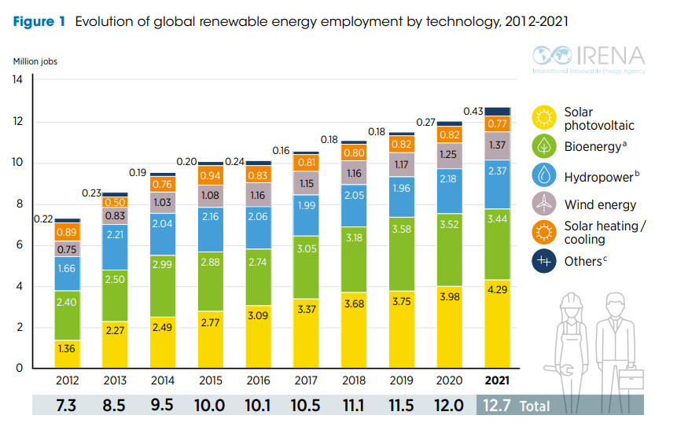

3.4 Policy Frameworks
UAE's proactive policy approach has been central to its energy transformation. Government has pledged ambitious targets for increasing the share of renewables and reducing carbon emissions under plans such as the UAE Energy Strategy 2050 and the Dubai Clean Energy Strategy 2050. The broader UAE Net Zero by 2050 initiative demonstrates the country's continued ambition on climate action. These policy frameworks are buttressed by regulatory tools like feed-in tariffs, net metering legislation, and support for public-private partnerships. Besides, the UAE's active leadership of global climate diplomacy, its position as a party to the Paris Agreement and host of COP28, shows its ambition for international climate action. Yet, the evolving nature of energy technologies necessitates ongoing policy development and adaptability. Figure 2 illustrates the centrality of these frameworks, showing a steep reduction pathway in carbon emissions, with the 2030 and 2050 milestones heavily dependent on effective policy implementation. [11], [12], [13]

3.5 Renewable Energy Integration

Sharjah presents an interesting case study of local renewable energy action. Advances in technology, reducing costs, and supportive local policy have built growing demand for clean energy solutions across the emirate. Sharjah has its own particular challenges to overcome, however, such as limited wind potential and the need for more sophisticated grid integration. This calls for the creation of regionally specific approaches rather than a one-size-fits-all approach. Government support, public involvement, and strong private sector alliances have been instrumental to Sharjah's success, offering valuable lessons for other emirates and nations wishing to emulate its example.

3.6 Global Commitments and the UAE's Role

The UAE has become a global leader in renewable energy adoption by connecting national efforts to international climate targets. Two instances of this include hosting COP28 and joining the UAE Consensus, which are examples of how the nation is leveraging its geopolitical influence to advance the world climate agenda. Through collaboration with international institutions and compliance with multilateral norms, the UAE both maximizes its global influence and advances its own national goals of energy security, economic diversification, and protecting the environment. Figure 2 underscores how these global commitments are not just symbolic but measurable, as the UAE’s emissions pathway directly aligns with international climate goals and the Paris Agreement’s long-term temperature targets. [13], [3]

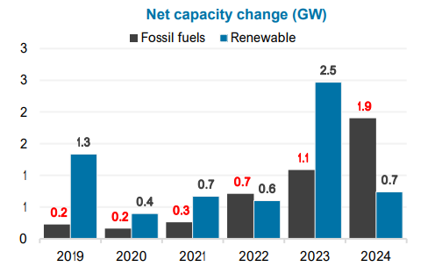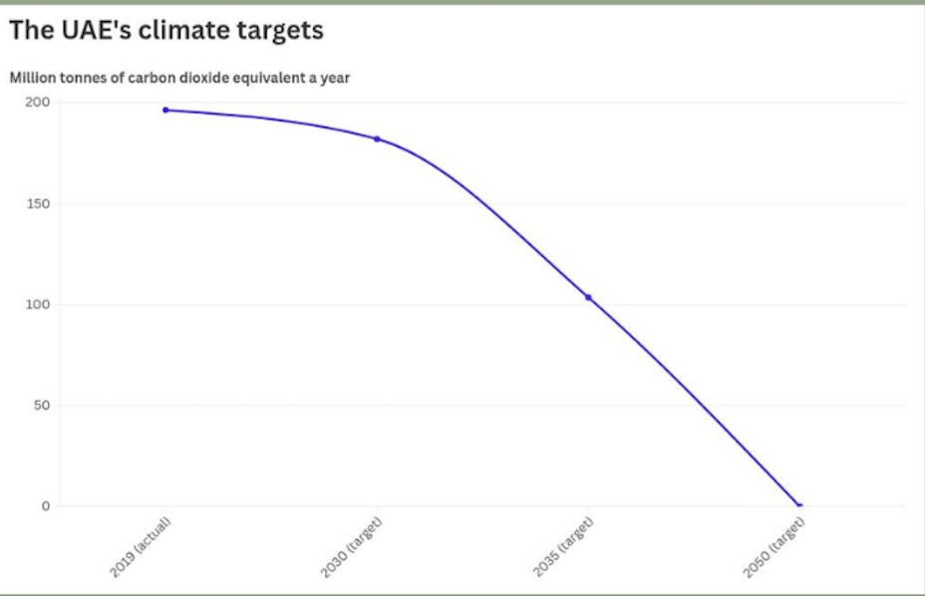

4. Methods & Results

4.1 Massive Infrastructure Projects

A key component of the UAE's green energy transformation is the establishment of large-scale renewable infrastructure. Ventures like the Mohammed bin Rashid Al Maktoum Solar Park in Dubai, the world's largest single-site solar park with a planned capacity of 5,000 MW by 2030, illustrate the nation's aggressive strategy in reconfiguring its energy mix. Similarly, the Barakah Nuclear Power Plant in Abu Dhabi contributes zero-carbon electricity to the national grid, reflecting the country's general strategy in diversifying its clean energy portfolio. The UAE also invests in the development of smart grids, for example, digitalization, to ensure the efficient integration of variable renewable energy. These mega-infrastructure projects have double objectives: reducing reliance on fossil fuels and creating economic activity in terms of construction, maintenance, and operations jobs. Importantly, as shown in Figure 3, such projects are critical if the UAE is to move away from the current trajectory of rising emissions under “Policies & action” (blue shaded area) and align instead with the steep reductions needed for the 1.5°C-compatible pathway by 2035. below is the picture of how Mohammed bin Rashid Al Maktoum Solar Park in Dubai will look like. [5], [6], [14]

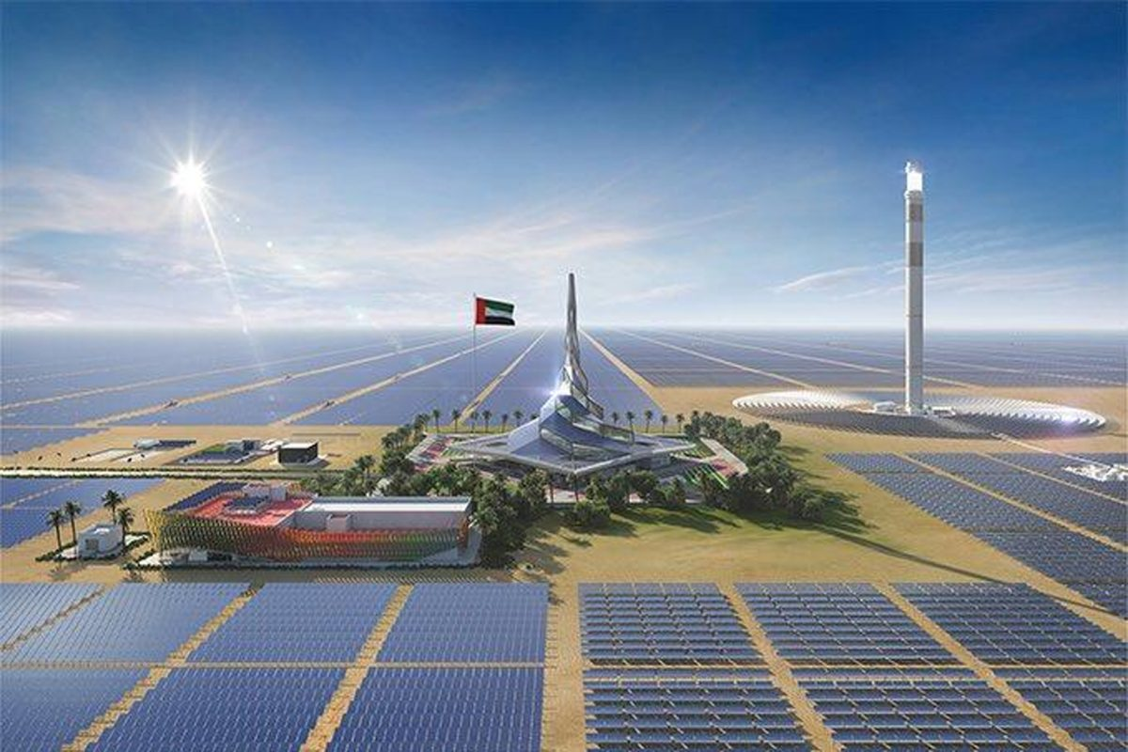

4.2 Adoption and Advancement of Technology

Technological advancement is at the heart of the UAE's renewable energy policy. One of the most serious drawbacks of renewable energy sources like solar and wind is their intermittence. To mitigate this, the UAE is going big on energy storage technologies like battery systems, pumped hydro storage, and hydrogen-based systems. Notably, the country is also setting itself up to be a global frontrunner in green hydrogen, with Dubai and Abu Dhabi developing solar-powered hydrogen production facilities set to supply both domestic consumption and export markets by 2050. In addition, artificial intelligence and Internet of Things (IoT) technologies are streamlining energy demand management and grid efficiency. Smart meters and artificial intelligence-based platforms are examples of the incorporation of digital technologies to bring sustainability and reliability to the energy industry. [15], [16], [11]

4.3 Strategic Policy Frameworks and Government Support

Government-driven policy-making and strategic planning have played a vital role in pushing the UAE towards a clean energy revolution. National initiatives such as the UAE Energy Strategy 2050 aim to increase the share of clean energy in the total energy mix to 50% and reduce carbon emissions by 70% by the year 2050. This is complemented by the Dubai Clean Energy Strategy 2050, which seeks to make Dubai a global hub for clean energy and green economy with a vision to produce 75% of its energy from clean sources. Policy measures are complemented by a range of regulatory incentives including net metering, feed-in tariffs, and encouragement of public-private partnerships. By creating a stable and foreseeable investment climate, the government ensures private sector operators are well placed to invest in and facilitate the transition. The importance of such strategic frameworks is reinforced by Figure 3, which shows that without stronger policy action, current commitments (2030 and 2035 NDC targets) fall short of the drastic reductions needed to achieve net zero by 2050. [11], [12]

4.4 Investment in Human Capital and Education
Realising that technological advancement must be coupled with skilled human resources, the UAE is heavily investing in education and training. Institutions such as Khalifa University and Masdar Institute have specialized programs in energy engineering, environmental science, and sustainable development to create a new breed of clean energy professionals. In addition to this, vocational and technical training centres are instilling the workforce with practical skills in solar panel installation, grid management, and energy auditing. The presence of such innovation hubs like Masdar City and organizations like the Dubai Future Foundation similarly speaks to the country's enthusiasm for research, development, and entrepreneurship in the clean tech industry. These moves collectively assure that the UAE green transformation is enabled by a functional, future-proofed workforce. In relation to Figure 3, such human capital investment provides the expertise needed to translate long-term targets, such as the 2050 net zero goal, into practical action and innovation that can sustain momentum in emissions reduction. [17], [18], [4]

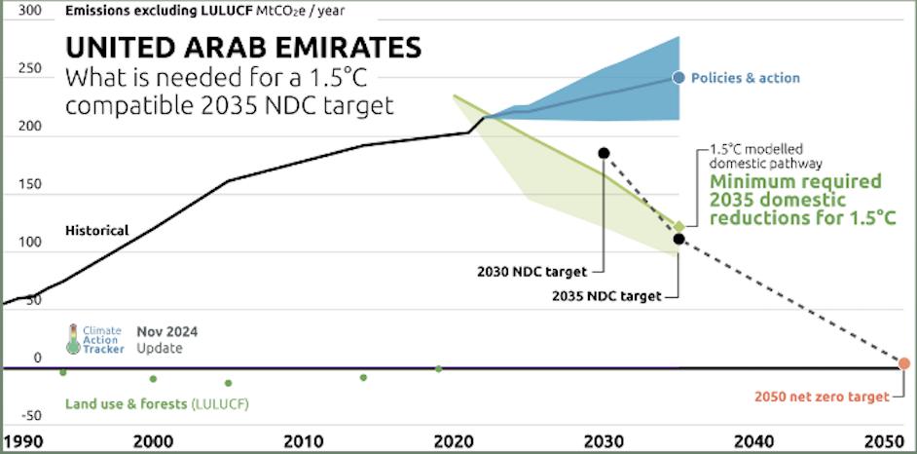
Climate Action Tracker [14]

5. Conclusion and Evaluation

The green transition of the UAE shows how it is possible for an economy based on hydrocarbons to turn towards a diversified and sustainable future. The commitment to decrease emissions by 47% by 2035 and to achieve net zero by 2050 [3] is an example of a climate target that is backed by tangible projects and measurable goals. Large-scale renewable energy innovation, including solar expansion to supply 29% of national electricity by 2030, is a classic illustration of the transformative power of infrastructure. Coupled with the contribution of nuclear and the extension of smart grids, these lower fossil fuel dependence, as well as generate jobs, stimulate the economy, and lay foundations for a modernized energy system. Together, they demonstrate that the energy transition is as much about economic competitiveness and resilience as it is about emissions mitigation.
Total final consumption (TFC) is the energy consumed by end users such as individuals and businesses to heat and cool buildings, to run lights, devices, and appliances, and to power vehicles, machines and factories. It also includes non-energy uses of energy products, such as fossil fuels used to make chemicals. Some of the energy found in primary sources is lost when converting them to usable final products, especially electricity. As a result, the breakdown of final consumption can look very different from that of the primary energy supply (TES). Both are needed to fully understand the energy system. [19]
Largest sources of energy in final consumption in United Arab Emirates, 2023 [19]

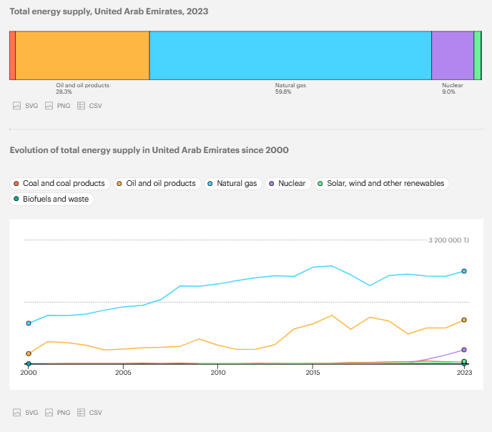
The UAE is also tackling at the same time the technical issues traditionally related to the uptake of renewable energy. Investments in battery storage, pumped hydro, and hydrogen-based energy systems are bringing clean electricity to market reliably and at scale, which allows reconciling solar and wind energy intermittency. The vision of green hydrogen leadership for the country also suggests that it is going to connect national sustainability with world export markets. Digitalisation policy initiatives, like grid management by AI and smart meters based on IoT, which enhance efficiency along the entire chain, provide technological momentum to this shift. In addition to energy, sectoral strategies such as reducing water production emissions by 93% and encouraging rapid adoption of electric vehicles in order to cut transport emissions by around 11% show that the UAE is facing multiple sources of carbon emissions simultaneously. These policies show a holistic approach where climate action, diversification, and innovation converge.
Most significantly, perhaps, these changes in technology and infrastructure are accompanied by solid government policies, education, and investments in human capital. Initiatives like the UAE Energy Strategy 2050 and Dubai Clean Energy Strategy 2050 provide regulatory stability and strategic guidance required to drive private investment as well as public–private partnerships. Concurrently, universities and research institutions like Khalifa University, Masdar Institute, and Masdar City are creating the next generation of clean energy and entrepreneurship leaders. Through the combination of policy frameworks with technological innovation and skill development, the UAE makes its aggressive climate ambitions feasible and sustainable in the long term. By such an approach, the UAE is not simply positioning itself to achieve the reductions in emissions depicted in Figure 3, but positioning itself as a regional leader in sustainability, setting an example for the manner in which policy, technology, infrastructure, and education can come together to drive a successful transition to a low-carbon future. [11], [12], [17], [18], [3]

REFERENCES
[1] International Energy Agency, “Net Zero Roadmap: A Global Pathway to Keep the 1.5 °C Goal in Reach,” 2023. [Online]. Available: https://www.iea.org/reports/net-zero-roadmap-a-global-pathway-to-keep-the-15-0c-goal-in-reach [Accessed: Jul. 20, 2026].
[2] International Renewable Energy Agency, “Renewable Energy Prospects: United Arab Emirates,” 2015. [Online]. Available: https://www.irena.org/-/media/Files/IRENA/Agency/Publication/2015/IRENA_REmap_UAE_report_2015.pdf [Accessed: Jul. 20, 2026].
[3] United Nations Framework Convention on Climate Change, “United Arab Emirates NDC 3.0,” 2024. [Online]. Available: https://unfccc.int/sites/default/files/2024-11/UAE-NDC3.0.pdf [Accessed: Jul. 20, 2026].
[4] International Renewable Energy Agency and International Labour Organization, “Renewable Energy and Jobs: Annual Review 2022,” 2022. [Online]. Available: https://www.irena.org/Publications/2022/Sep/Renewable-Energy-and-Jobs-Annual-Review-2022 [Accessed: Jul. 20, 2026].
[5] Dubai Electricity and Water Authority, “Mohammed bin Rashid Al Maktoum Solar Park,” 2025. [Online]. Available: https://www.dewa.gov.ae/en/about-us/strategic-initiatives/mbr-solar-park [Accessed: Jul. 20, 2026].
[6] Emirates Nuclear Energy Company, “Barakah Nuclear Energy Plant,” 2024. [Online]. Available: https://www.enec.gov.ae/barakah-plant/ [Accessed: Jul. 20, 2026].
[7] CBRE, “The UAE Sustainability Report 2023,” 2023. [Online]. Available: https://www.cbre.ae/insights/reports/the-uae-sustainability-report-2023 [Accessed: Jul. 20, 2026].
[8] C. Arndt, M. Miller, F. Tarp, O. Zinaman, and D. Arent, “Faster Than You Think: Renewable Energy and Developing Countries,” Annual Review of Resource Economics, vol. 11, pp. 149–168, 2019. https://doi.org/10.1146/annurev-resource-100518-093759 [Accessed: Jul. 20, 2026].
[9] International Energy Agency, “From Taking Stock to Taking Action,” 2024. [Online]. Available: https://www.iea.org/reports/from-taking-stock-to-taking-action [Accessed: Jul. 20, 2026].
[10] Dubai Future Foundation, “Hydrogen: From Hype to Reality,” 2021. [Online]. Available: https://www.dubaifuture.ae/wp-content/uploads/2021/10/Hydrogen-From-Hype-to-Reality-EN-v1.0.pdf [Accessed: Jul. 20, 2026].
[11] Ministry of Energy and Infrastructure, United Arab Emirates, “Updated UAE Energy Strategy 2050 and National Hydrogen Strategy,” 2023. [Online]. Available: https://www.moei.gov.ae/en/media-center/news/4/7/2023/minister-of-energy-and-infrastructure-reveals-details-of-the-updated-uae-energy-strategy-2050-and [Accessed: Jul. 20, 2026].
[12] The Official Portal of the UAE Government, “Dubai Clean Energy Strategy,” 2024. [Online]. Available: https://u.ae/en/about-the-uae/strategies-initiatives-and-awards/strategies-plans-and-visions/environment-and-energy/dubai-clean-energy-strategy [Accessed: Jul. 20, 2026].
[13] United Nations Framework Convention on Climate Change, “COP28 Agreement Signals “Beginning of the End” of the Fossil Fuel Era,” 2023. [Online]. Available: https://unfccc.int/news/cop28-agreement-signals-beginning-of-the-end-of-the-fossil-fuel-era [Accessed: Jul. 20, 2026].
[14] Climate Action Tracker, “United Arab Emirates,” 2024. [Online]. Available: https://climateactiontracker.org/countries/uae/ [Accessed: Jul. 20, 2026].
[15] Dubai Electricity and Water Authority, “Smart Grid,” 2024. [Online]. Available: https://www.dewa.gov.ae/en/about-us/strategic-initiatives/smart-grid [Accessed: Jul. 20, 2026].
[16] Dubai Electricity and Water Authority, “Hatta Hydroelectric Power Plant,” 2025. [Online]. Available: https://www.dewa.gov.ae/en/about-us/strategic-initiatives/hydroelectric-power-plant-in-hatta [Accessed: Jul. 20, 2026].
[17] Khalifa University, “Academic Programs and Research,” n.d.. [Online]. Available: https://www.ku.ac.ae/ [Accessed: Jul. 20, 2026].
[18] Masdar City, “Innovation and Sustainability Ecosystem,” n.d.. [Online]. Available: https://masdarcity.ae/ [Accessed: Jul. 20, 2026].
[19] International Energy Agency, “United Arab Emirates: Energy Mix,” n.d.. [Online]. Available: https://www.iea.org/countries/united-arab-emirates/energy-mix [Accessed: Jul. 20, 2026].

